**ISOLATION OF INFECTIOUS MICROBES FROM INSECTS FOUND IN HOSPITAL ENVIRONMENT**

**BY**

**EMEJURU EKENE REGINALD**

**2019/24903**

**DEPARTMENT OF MICROBIOLOGY**

**FACULTY OF BIOLOGICAL SCIENCES**

**UNIVERSITY OF NIGERIA, NSUKKA**

**JUNE 2024**

**TITLE PAGE**

ISOLATION OF INFECTIOUS MICROBES FROM INSECTS FOUND IN HOSPITAL ENVIRONMENT

**APPROVAL PAGE**

This is to certify that this project has been presented to the Department of Microbiology, Faculty of Biological Sciences in partial fulfilment for the award of Bachelor of Science (B.Sc) degree in Microbiology.

BY

EMEJURU EKENE REGINALD

2019/249038

….…………………….

..…………………… ………………….

PROF. E.I. NWEZE MR C.C. EZEH

PROJECT SUPERVISOR PROJECT COORDINATOR

DATE………………..

….……………………….

REV. SR. PROF. M. E. U. DIBUA

HEAD OF DEPARTMENT

DATE………………………

**DEDICATION**

This work is dedicated to Almighty God for his guidance and provision throughout the process of writing this research study.

**ACKNOWLEGEMENT**

My sincere gratitude to Prof. E. I. Nweze, my supervisor, for his patience, understanding and guidance throughout the process of this research. I sincerely appreciate the HOD Rev. (Sr) Prof. M.E.U. Dibua and all the staff of the Department of Microbiology, University of Nigeria Nsukka,for their hardwork in grooming us to be better students. Thanks also to Mr. Chidebelu Paul Ekene (Sir Paul) who provided helpful insights and assistance throughout the process of writing this work. Special thanks to my family, and friends for their love, care and understanding and to my project partner Uchendu Faith Onyinye for her assistance throughout the process of writing this research work.

**ABSTRACT**

Hospitals, being sterile environments for patient treatment and care, can face challenges to their cleanliness due to insects like cockroaches, flies, mosquitoes e.t.c. These insects can introduce infectious microorganisms to the hospital environment thereby compromising the sterility of the healthcare setting. This study aimed to isolate and identify pathogenic microorganisms from insects in hospital environments and assess their antibiotic susceptibility. Insects such as dragonflies, houseflies, spiders, soldier ants, and centipedes were collected from various hospital locations. These insects were examined using nutrient agar, MacConkey agar, blood agar, and Sabouraud dextrose agar to culture bacteria. The morphological and biochemical tests identified multiple pathogenic bacteria, including *Escherichia coli*, *Staphylococcus aureus*, *Pseudomonas aeruginosa*, and *Klebsiella pneumoniae*. Specifically, 86 isolates were identified, with 23 selected for antimicrobial susceptibility testing. The study revealed that *Bacillus spp* showed the highest occurrence (30.43%) among the isolates, while *Morganella spp*, *Corynebacterium spp*, and *Staphylococcus aureus* showed the least level of occurrence. Antibiotic susceptibility testing demonstrated significant resistance to commonly used antibiotics, including ampicillin, tetracycline, and ciprofloxacin. *Pseudomonas* *spp* exhibited high resistance, with 80% of the isolates showing resistance to multiple antibiotics. *Morganella spp* and *Proteus spp* were found to be 100% susceptible to certain antibiotics but also showed resistance to others, indicating a varied resistance profile. Multi-drug resistant (MDR) organisms were identified, including *Enterobacter spp* and *Escherichia coli*, with resistance indices indicating significant challenges in treatment. These results suggest that hospital insects are carriers of antibiotic-resistant pathogens, highlighting their potential role in the transmission of hospital-acquired infections (HAIs) and the necessity for robust pest control and infection prevention strategies in healthcare settings**.**

**TABLE OF CONTENTS**

TITLE PAGE i

APPROVAL PAGE ii

DEDICATION iii

ACKNOWLEDGEMENT iv

ABSTRACT v

TABLE OF CONTENTS vi-vii

LIST OF FIGURES ix

LIST OF TABLES x

**CHAPTER ONE** 1

**1.0 INTRODUCTION** 1

1.1 Aim of the Study 2

1.2 Objectives of the study 2

1.3 Statement of the Problem 2

1.4 3 Literature Review 3

1.4.1 Overview of Hospital-Acquired Infections 3

1.4.2 Role of Insects In Spreading Infectious Microbes 4

1.4.3 Insects Commonly Found in Hospitals 5

1.5 Bacterial Infections Commonly Associated with Insects Found in The Hospitals.

1.6 Fungal Infections Commonly Associated with Insects Found in The Hospitals.

1.7 Infection Control Measures

**CHAPTER TWO**

**2.0 METHODS AND METHODOLOGY**

2.1 Study areas

2.2 Collection of insects

2.3 Media Preparation

2.4 Sample Preparation and Inoculation

2.5 Macroscopy

2.6 Microscopy

2.7 Biochemical Test

2.7.1 Catalase Test

2.7.2 Tripple Sugar Ion Test

2.7.3 Citrate Test

2.7.4 Urease Test

2.7.5 Methyl Red Test

2.7.6 Voges Proskauer Test

2.7.7 Oxidase Test

2.7.8 Sulphur, Indole and Motility (SIM) Test

2.8 Fungal Test

2.8.1 Lactophenol Blue Staining for Yeasts

2.8.2 Slide Culture Technique for Moulds

2.9 Antimicrobial Susceptibility Test

2.9.1 Procedure for Mac-Farland’s standard

2.9.2 Inoculum preparation

**CHAPTER THREE**

**3.0 RESULTS**

**CHAPTER FOUR**

**4.0 DISSCUSSION**

**CONCLUSION**

**REFERENCES**

**LIST OF FIGURES**

1 A specie of an ant (*Eciton burchelli*) 5

2 An adult cockroach 6

3 Dragonfly 7

4 A map showing the study areas (Medical Centre and Faith Foundation Hospital) 10

5 Frequency of bacteria isolates in each hospital 25

6 Total number of bacteria isolates occurrence in both hospitals 26

7 Colony morphology of bacteria isolates 37

8 Microscopic appearance of Gram negative bacteria 37

9 Colony morphology of fungi 38

10 Microscopic view of *Aspergillus* s*pp*  38

**LIST OF TABLES**

1.Morpholological characteristics of bacteria isolates 19

2. Morphological characteristics of bacteria isolates continues 20

3 Microscopic characteristics of bacteria isolates 21

4 Phenotypic tests results and suspected organism 23

5 Antimicrobial susceptibility results of isolates against Gram negative disc 29

6 Antimicrobial susceptibility results of isolates against Gram positive disc 30

7 Identification of fungal isolates 39

**CHAPTER ONE**

1. **INTRODUCTION**

Insects can act as vectors, transmitting infectious microbes to humans in healthcare settings. Several studies have isolated pathogenic bacteria from insects collected in hospitals. The presence of insects in hospital environments and healthcare facilities is a potential public health risk due to their possible role in the epidemiology of nosocomial infections. In particular, some of these insects are involved in the dissemination of multi-drug resistant (MDRs) pathogens, thereby posing a great threat in the clinical setting. According to WHO (World Health Organization), multi-drug resistance increases costs of diagnosis and treatment of infections (World Health Organization (WHO 2001)).

Insects are considered vectors of pathogens. They transfer microorganisms from decaying matter, waste, or faeces to objects and food, posing the risk of infection in humans. Among insects, various species of flies, ants, and cockroaches play a crucial role (Wiktorczyk-Kapischke *et al*., 2021).

Insects represent the most successfully adapted group of animals on Earth, with over 1.5 million identified species (Belluco *et al*., 2023). Insects have established themselves in nearly every imaginable habitat and form the biological basis of all terrestrial ecosystems. They play critical roles such as decomposing and cycling nutrients, dispersing seeds, maintaining soil structure and fertility, and regulating populations of other organisms through various roles, including predators, parasites, parasitoids, disease agents, and vectors. Additionally, insects are a crucial food source for numerous other taxa, including amphibians, reptiles, birds, fish, arthropods, other invertebrates, and mammals (Van Huis, 2013).

The widespread presence and diverse ecological niches of insects make them significant to

public health from multiple viewpoints. In addition to their essential ecological functions, insects

can impact public health by transmitting diseases to humans and animals. Biting insects, in particular, act as vectors and pests. With climate change and rising resistance among arthropods to insecticides, the prevalence and significance of vector-borne diseases are anticipated to grow in the near future (Poma *et al*., 2017).

**1.1 Aim**

The aim of this research is to isolate and identify pathogenic microorganisms from insects in hospital environments and to determine the antibiotic susceptibility of the bacteria isolated from these insects.

**1.2 Objectives of this research**

1. To isolate microorganisms from insects found in the selected hospitals .
2. Characterization and identification of the isolates based on culture, microscopy and biochemical tests.
3. To evaluate the antimicrobial susceptibility profile of the isolates.
4. To evaluate the level of occurrence of each organisms from the hospital of origin.

**1.3 Statement of the problem**

Despite strict sanitation protocols, hospital-acquired infections (HAIs) remain a major concern. Insects in hospital environments may contribute to the spread of infectious microbes, posing risks to patients and healthcare workers. This study aims to isolate and identify these pathogens. from hospital insects and assess their antibiotic resistance, to better understand and mitigate their role in HAIs.

**1.4 Literature review**

Healthcare-associated infections (HCAIs) are a significant cause of illness and death, ranking as the second most common cause of mortality worldwide (Ricchizzi *et al*., 2018).

According to the World Health Organization (WHO) and other researchers, approximately 7% of patients in high-income countries and 10% in emerging and developing economies contract at least one type of healthcare-associated infection (HCAI), with a mortality rate of 10% among affected patients (Danasekaran *et al*., 2014).

**1.4.1 Overview of Hospital-Acquired Infections**

Healthcare-associated infections (HCAIs) are infections that patients develop during the course of receiving medical care (Collins, 2008).

The term healthcare-associated infections (HCAIs) originally referred to infections associated with admission to acute-care hospitals, previously known as nosocomial infections. However, the definition has expanded to encompass infections acquired in a variety of healthcare settings, including long-term care facilities, family medicine clinics, home care, and ambulatory care. HCAIs are defined as infections that manifest 48 hours or more after hospitalization or within 30 days following receipt of healthcare services (Revelas, 2012).

In developing countries, the incidence of healthcare-associated infections is three times higher compared to the rates observed in adult intensive care units in the United States (Allegranzi *et al.*, 2011).

**1.4.2 Role of Insects in Spreading Infectious Microbes**

Arthropod vectors act as natural reservoirs and transmitters of numerous arboviruses. Within these vectors, symbiotic microorganisms located in the gut lumen and hemocoelic tissues establish complex relationships with their hosts, affecting various aspects of vector physiology (Yin *et al.,* 2020).

The most recognized public health concern regarding insects is their role as vectors of pathogens. Arthropods are capable of transmitting various infectious agents, including bacteria, parasites, protozoa, and viruses, leading to over 700,000 deaths annually from vector-borne diseases worldwide (Belluco et al., 2013).

In this context, arthropods are categorized into mechanical vectors and biological vectors. Mechanical vectors, typically non-blood-sucking insects such as cockroaches and flies, transmit pathogens through physical contact after coming into contact with feces, sewage, or other biological fluids. These vectors then spread contamination to the environment and food. Biological vectors, including mosquitoes, sand flies, fleas, and ticks, are generally blood-sucking parasites that acquire pathogens through blood meals from infected hosts. Within these vectors, pathogens multiply and/or complete a phase of their development cycle, subsequently being transmitted to multiple hosts through bites. Despite advancements in prevention and control measures, including diagnosis, treatment, vaccination, and vector control methods, vector-borne diseases continue to emerge and remain significant public health concerns worldwide (Garofalo *et al.,* 2017).

Furthermore, the burden of vector-borne diseases is influenced by a complex interplay of demographic, environmental, and social factors. A key contributor is the increased interaction

between humans, animals, and vectors, which disproportionately affects impoverished populations, particularly in tropical and subtropical regions (Fasolato *et al*., 2018).

**1.4.3 Insects Commonly Found in Hospitals**

**Ants**

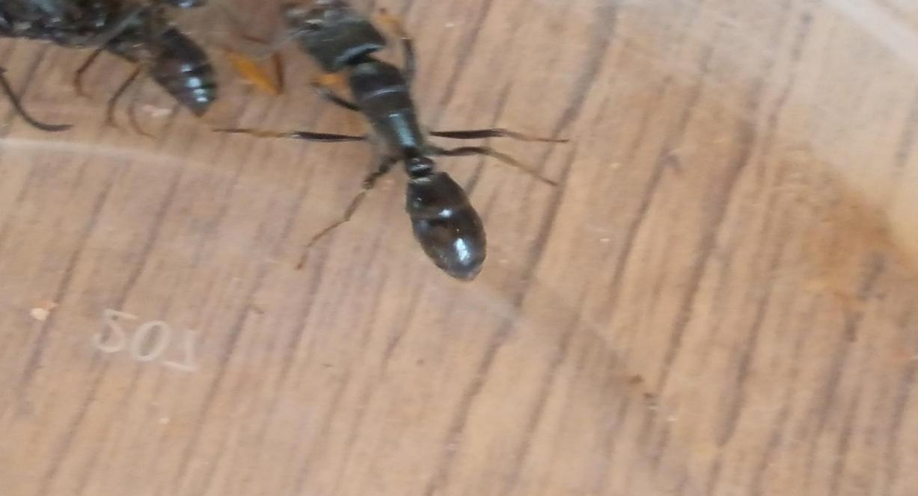

Figure 1: A soldier ant (*Eciton burchelli*)

Ants are social insects that coexist with humans and easily adapt to urban environments. Their presence can negatively impact human quality of life due to potential damage and health threats. Hospitals are particularly susceptible to ant infestations, which can facilitate the propagation and spread of pathogenic microorganisms (Fonseca *et al*., 2010).

The presence of ants in hospitals has garnered research attention due to the risks they pose to patients and healthcare professionals. Additionally, urban hospital environments experience compromised healthcare quality due to the proliferation of microbial vectors (Fontana *et al.,* 2010).

**Housefly**

House flies (*Musca domestica*) are widespread pests found in diverse environmental habitats worldwide. They thrive in environments abundant with microbes, crucial for the growth and survival of their larvae (Zurek *et al*., 2000).

Due to their mobility, adult house flies come into contact with microbes from different areas within a facility that would not normally interact. House flies are commonly found resting on physical structures like buildings, equipment, fences, and feed storage areas, as well as on

animals themselves. They have a wide-ranging diet, consuming various substances including human and livestock food, as well as excreta. Female flies ingest microbe-rich substrates such as manure, possibly driven by opportunities during egg-laying or an as-yet-unknown need for microbial nutrition. (Thomson *et al*., 2016).

**Cockroach**

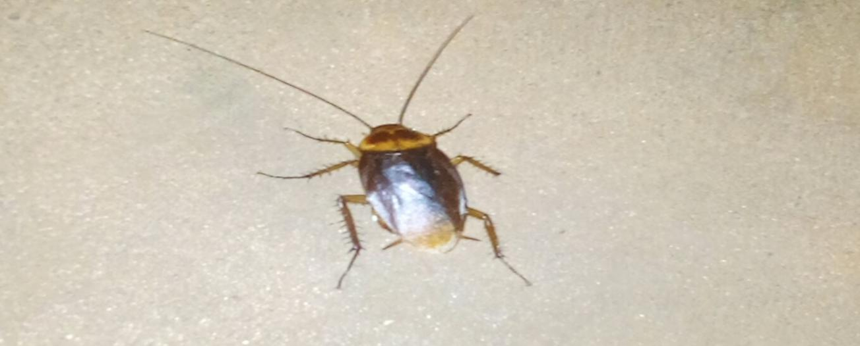

Figure 2: An adult cockroach

Cockroaches are highly adaptable to diverse environmental conditions, allowing them to inhabit all regions across the globe. There are approximately 4000 species of cockroaches known to exist (Donkor, 2019).

Cockroaches are a significant concern in hospital environments due to their potential role as reservoirs and carriers of pathogens that cause hospital-acquired infections (nosocomial infections). Several studies have documented the presence of microbes carried by cockroaches in hospitals (Naher *et al.,* 2018).

Previous research has predominantly focused on bacteria and, to a lesser extent, parasites and fungi, with limited attention given to viruses. One study found that 19.7% of cockroaches collected at a tertiary hospital in Ghana carried rotavirus. Rotavirus is a leading cause of severe and potentially fatal diarrhea in young children globally, contributing significantly to hospitalizations due to diarrheal diseases in children under five years old in developing nations. Nosocomial transmission of rotavirus appears to account for approximately 25% of all rotavirus-related hospitalizations, particularly affecting immunocompromised children (Donkor, 2019).

**Dragonflies**

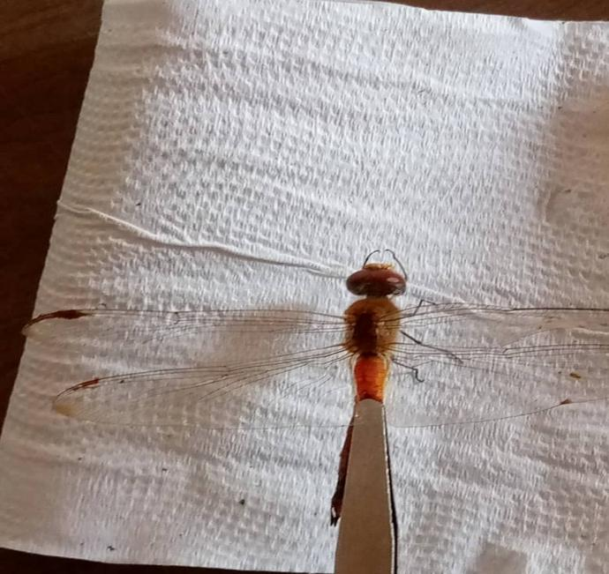

Figure 3: Dragonfly

Dragonflies (*Odonata*) may serve as vectors for the dissemination of pathogenic microorganisms in healthcare settings, posing a potential risk to patient safety. Dragonflies may harbor microorganisms on their bodies, including bacteria, viruses, and fungi and can infiltrate hospitals through various entry points, including open windows, doors, and ventilation systems. Dragonflies may deposit microbial contaminants on surfaces upon landing, posing a risk to environmental hygiene. The contaminated surfaces may also serve as a source of infection transmission to healthcare workers and patients, posing a particular risk to individuals with weakened immune systems or open wounds (Yasen *et al*., 2018)

**1.5 Bacterial Infections Commonly Associated With Insects Found In The Hospital**.

***Pseudomonas aeruginosa***

*Pseudomonas aeruginosa* is a gram-negative, rod-shaped bacterium that is commonly found in the environment, particularly in water and soil. It is an opportunistic pathogen that can cause a range of infections. *P. aeruginosa* is known for its ability to form biofilms, which are complex communities of bacteria that are embedded in a protective matrix. This makes it resistant to antibiotics and the host's immune system (Akpan *et al.*, 2017). Insects can acquire *P. aeruginosa* through contact with contaminated surfaces, feeding on infected materials, interaction with infected animals or humans, contaminated water sources, soil and decaying organic matter, and through vector transmission ( insects like mosquitoes and flies can transmit *P. aeruginosa* from one location to another through their movements and feeding activities. These routes of acquisition highlight the importance of maintaining proper hygiene, sanitation, and infection control practices to minimize the risk of *P. aeruginosa* transmission in hospital environments.

***Enterococcus* *spp***

*Enterococcus* species for instance *Enterococcus feacalis* and *Enterococcus feacium* has been found to reside in insects around hospital environment. They are also responsible for *Staphylococcus aureus* resistance to vancomycin (Rawat *et al.*, 2023).  *E. feacalis* causes a broad range of nosocomial Infections including urinary tract infections (UTI's), bloodstream infections, endocarditis (infection of the heart valves, meningitis, respiratory tract infections (Parlapani *et al*., 2020). *Enterococcus* species can be picked by insects through contaminated surfaces, decaying organic matter and then transport them to other areas of the hospital including patients surroundings, operating rooms and intensive care unit. Proper cleaning and disinfection of surfaces, elimination of water and moisture, use of insect traps and repellents are measures that can be taken to curb the transmission of *Enterococcus* spp.

**1.6 Fungal infections commonly associated with nosocomial insects.**

*Aspergillus, Candida, Fusarium* and *Saccharomyces cerevisae* has been found to be associated with insects in hospital environments, which can lead to the spread potentially harmful infections (Fürnkranz and Walochnik, 2021). Cockroaches, flies, beetles and ants can pick up these fungi spores from contaminated surfaces, soil, and decaying organic matter, and can then transport them to other areas of the hospital, including patient rooms, operating rooms, and intensive care units. The presence of insects in hospitals can lead to the spread of *Aspergillu*s and other fungi, which can cause a range of health problems, including allergic reactions, respiratory infections

**1.7 Infection Control Measures**

The strategies for controlling and preventing hospital infections are diverse and intricate, addressing a spectrum of factors from the engineering of hospital infrastructure and maintenance practices, to policy decisions regarding vaccination protocols, to the promotion of personal hygiene among both healthcare staff and patients (Breathnach, 2013).

**CHAPTER TWO**

* 1. **MATERIALS AND METHODS**

**2.1 Study areas**

The study samples (insects) were obtained from Medical Centre Hospital and Faith Foundation Hospital. Both hospitals are located in Nsukka Enugu state.provide comprehensive medical services, including ophthalmology, radiology, orthopedics, obstetrics, and gynecology, to the residents of the town and surrounding rural areas.



* 1. **Collection Of Insects**

The insects were first caught from the hospital environment, using various methods such as handpicking with sterile gloves, forceps and net trap.

Insects like Dragon fly, House fly, Spider, Soldier ant and Centipede were collected at the Medical center, while house fly, centipede, soldier ant, cricket, deer fly and black fly were collected at Faith foundation hospital and stored viable in sterile bottles.

* 1. **Media Preparation**

The media was prepared according to the manufacturer’s instruction; media that was prepared was nutrient agar, MacConkey agar and blood agar.

Nutrient agar is a general purpose medium used for the cultivation of microorganisms, the media was boiled for 10mins to homogenize then sterilized by autoclaving at 121oC and 15pound pressure for 15minutes, allowed to cool to 45oC and then dispensed aseptically into sterilized and labelled petri-dishes and allowed to solidify.

MacConkey agar is a differential media used for the cultivation of gram negative enteric bacteria, such as those in the Enterobacteriaceace family, the media was boiled for 10mins to homogenize then sterilized by autoclaving at 121oC and 15pound pressure for 15minutes, allowed to cool to 45oC and then dispensed aseptically into sterilized and labelled petri-dishes and allowed to solidify.

Blood agar is used for isolation and identification of bacteria, especially those that require blood for growth, such as *Streptococcus* and *Staphylococcus*. It is also used to detect hemolytic activity, which is the ability of bacteria to break down red blood cells. the media was boiled for

10mins to homogenize then sterilized by autoclaving at 121oC and 15pound pressure for 15minutes, allowed to cool to 45oC and then dispensed aseptically into sterilized and labelled petri-dishes and allowed to solidify.

**2.4 Sample Preparation And Inoculation**

The insects were grounded using a sterile motar and pestle a sterile spatula is used to add the crushed insects into a sterile test tube and 1ml of peptone water is added to the test tube(the peptone water serve as enrichment media) and the test tube is then shaken for 2mins then incubated for an hour so as to revive the viable bacteria. After incubating for 1 hour, micro pipette are then used to collect the liquid samples which are innoculated on macckonkey agar, SDA agar, mannitol salt agar, blood agar and nutrient agar using a spreader to achieve an even distribution. It is then incubated for 24 hours at 37 degree celcius but the SDA was left for 48 hours at 37 degree celcius

After 24 hours, growth was observed in macckonkey, mannitol, blood and nutrient plate media. The colonies were then subcultured on nutrient agar to obtain a pure colony of the organisms. After 24 hours, slant cultures were prepared to store the isolates/organisms.

For the fungal species, the SDA plate was subcultured after 48 hours to obtain a pure colony. After that an SDA slant was prepared to store those isolates

After the completion of the subculturing process, different identification tests such as morphological and biochemical tests were carried out including: macroscopy, microscopy, citrate test, triple sugar iron test, indole, motility, methyl red, voges prokaeur, urease, catalase and oxidase tests..

* 1. **Macroscopy**

The morphological characteristics of the colonies of the different isolates such as colour, shape, elevation, edge, density and texture were observed after the growth of the organism on the solid media.

* 1. **Microscopy**

The isolate is smeared on a sterile slide and heat-fixed using a bursen flame, Crystal violet stain is applied, followed by iodine then a decolorizer is used to remove some of the stains after which a safranin counterstain is applied to give a contrasting color, the slide is then rinsed and dried before being examined under a microscope with oil immersion

After the examination, the bacteria will be stained either purple (gram-positive) or pink (gram-negative) which will be used in their classification.

* 1. **Biochemical tests**

The following tests were carried out for the further confirmation of various organisms:

* + 1. **Catalase test**

This is used to determine if the isolate is able to produce the enzyme, catalase. Using a sterile inoculating loop, a single colony was picked and placed on the surface of a clean and dry glass slide and a drop of 3% Hydrogen peroxide was placed on the slide and absence of bubbles is negative for catalase activity while presence of bubbles is positive for catalase activity.

**2.7.2 Triple sugar ion Tes**t

This test is used to check for organisms that can degrade sulphur-containing amino acids to H2 S by innoculating the test organism on TSI medium. Production of H2S is indicated by the change of colour of the medium to black/brown (Ezeonu *et al.*, 2011).

* + 1. **Citrate test**

The citrate test is a biochemical test used in microbiology to determine whether an organism can utilize citrate as its sole carbon source. This test helps in the differentiation and identification of bacteria based on their ability to metabolize citrate.

Using a sterile loop, a single colony of the test organism from an agar plate was picked and inoculated it into a tube of Simmons citrate agar. The inoculation was gentle to avoid damaging the agar surface. The inoculated tube was then securely capped and placed in an incubator set to 37°C. The tube was incubated for 24-48 hours, checking periodically for any color changes or grow. After the appropriate incubation period, The Simmons citrate agar slant was examined for any visible changes. Specifically, for a change in color of the agar from green to blue, which

indicates utilization of citrate. A positive result would be indicated by a deep Prussian blue color throughout the slant, suggesting the organism has utilized citrate as a carbon source. A negative result would show no color change, with the agar remaining green.

* + 1. **Urease test**

Urease solution was prepared, containing 95% urea agar and 5% urea salt. Slants were made with solution in bijou bottles, and the test organism was inoculated and incubated at 37oc for 24h. Urease positive organisms produce urease enzymes that hydrolyze urea to produce ammonia, which is alkaline. This reaction turns the medium pinkish-red for positive result.

* + 1. **Methyl red test**

Materials required: MRVP broth, methyl red, test tubes, ethanol, distilled water, dropper, fresh culture, alpha naphtol, KOH.

The MRVP broth was prepared according to the manufacturer’s specification distributed into test tubes, sterilized by autoclaving, allowed to cool to room temperature and labeled. The broth was inoculated with the isolates from fresh culture and incubated at 37oc for 24h. after incubation, 1ml aliquot was taken into a test tube and 2-3 drops of freshly prepared methyl solution added. It was observed for immediate colour change from yellow to red and result taken.

**2.7.6 Voges-Proskauer’s test**

For Voges-Proskauer’s test 1.5ml of 5% alpha-naphthol and 0.5ml of KOH are added to the test-tubes used for methyl red test and are shaken vigorously and allow to stand for 5mins. A red-pink colour at the surface/ top of the medium is observed for a positive result.

* + 1. **Oxidase test**

A piece of filter paper is soaked with a few drops of oxidase reagent. A colony of the test organism is smeared on the surface of the paper. When the organism is oxidase producing, the phenylenediamine in the reagent will be oxidized to a deep blue colour within 10 mins for positive result, but a faint purple colour or no colour after 1minute indicate a negative result.

Before the oxidase test is carried out, the isolates are grown on Simmon’s citrate agar.

**2.7.8 Sulphur, indole and motility (SIM)**

This test is used to check for sulphur, indole and motility. A conical flask containing casein peptone, ferric ammonium citrate, meat peptone, agar, sodium thiosulphate and distilled water was prepared and sterilized for 15mins. After sterilization, it was then dispensed into sterile test tubes. A sterile innoculatng needle was used to touch the center of a well-isolated colony and aseptically stab once to a depth of 1/3 inch in the middle of the test tubes. The test tubes were then incubated aerobically at 37 C. Presence of black color indicates sulphur positive.

Indole: add a few drops of kovac’s reagent. Appearance of the red ring after addition of reagent indicates a positive result while no colour change after addition of reagent signifies a negative result.

Motility: observe for a fuzzy growth from the stab line by holding a white paper behind the test tubes.

**2.8 Fungal test**

**2.8.1 Lactophenol blue staining for yeasts**

A drop of lactophenol blue is dropped on a sterile, clean, greeze-free slide, using a sterile wire loop, a colony of the test organism was smeared on the slide. A sterile cover slips was used to cover the slide gently to avoid air bubbles. The specimen was viewed under a compound microscope using a very high power objective lens. The specimen was observed under the microscope to identify any yeast.

**2.8.2 Slide culture technique for moulds**

An SDA plate was prepared and sterilized, poured on a petri-dish and allowed to gel. The media was cut off in block shape and placed on top of filter paper, glass bent rod and slide in a sterile petri dish. it was then incubated at room temperature for 5 days. The filamentous fungi was then checked for under the microscope.

**2.9 Antimicrobial susceptibility test (disc diffusion method)**

The isolates were first subcultured on nutrient media for 24 hours at 37 degree celcius .

Normal saline was then prepared and sterilized for 20mins (2.125g of Nacl in 250mls of distilled water).

**2.9.1 Procedure for Macfarland’s standard**

In order to standardize microbial testing, the turbidity of bacterial suspensions is adjusted using MacFarland standards as a guide to ensure that the quantity of bacteria falls within a specified range. It was made by combining 1% of sulphuric acid (H 2SO4) with 1% of anhydrous barium chloride (BaCl2). After being well combined to create a turbid mixture, this was put in storage. A sterile test tube containing 0.5 ml of 1% BaCl2 and 0.5 ml of 1% H 2SO4 is used to generate a 0.5 Macfarland's standard. After that, 9.9 ml of distilled water is poured to the tube and combined to create a turbid suspension.

**2.9.2 Innoculum Preparation**

Inoculum for the sensitivity test was prepared by suspending the isolates in about 2ml of normal saline, using a sterile wire loop. The turbidity was adjusted to 0.5 MacFarland’s standard. A sterile swab stick was then dipped into the broth culture of the test organism. The swab stick was then streaked on an already prepared muller hinton agar plate and left for 15 minutes before placing the antimicrobial disk on the surface of the recently innoculated muller hinton agar. It was then incubated for 18 hours at 37. After incubation, sensitivity of test organism to the antibiotic drugs was determined by using a metric ruler to measure the diameter of the zone of inhibition of each antibiotics used. The zone of inhibition was measured in millimeters (mm).

**CHAPTER THREE**

**3.0 RESULTS**

A total of 86 isolates were isolated from those insects collected from both hospitals. Twenty-three isolates were identified and selected for antimicrobial susceptibility study.

**3.1 Colony Morphology and Identification**

The morphological features of the isolate on macconkey, mannitol salt agar, blood agar and nutrient was identified. The bacteria isolates were grouped according to their colour, shape, margin, elevation, texture and the media being cultured on (Table 1).

**3.2 Microscopic Morphology of the Bacteria isolates.**

The microscopic morphology of all the bacteria isolates during Gram staining was identified. Bacteria isolates with similar microscopic morphology were grouped together. The morphological features used in identifying and grouping the isolates include the Gram reaction, shape and arrangement (Table 2).

**Table 1: Morphological characteristics of bacteria isolates.**

|  |  |  |  |  |  |  |
| --- | --- | --- | --- | --- | --- | --- |
| **Isolates code**  **and source** | **Colour** | **Shape** | **Margin** | **Elevation** | **Texture** | **Media** |
| MC1(Housefly) | White | Circular | Entire | Flat | Smooth | Blood agar |
| MC7(Dragonfly) | Yellow | Circular | Entire | Convex | Glistening | Mannitol agar |
| MC26(Spider) | Yellow | Irregular | Irregular | Convex | Smooth | Mannitol agar |
| MC32(Millipede) | Pale pink | Irregular | irregular | Slighly raised | Smooth | Mannitol agar |
| MC2(Dragonfly) | Pink | Circular | Slighly irregular | Convex | Glistening | Macconkey |
| MC19(Dragonfly) | Greenish | Circular | Entire | Slighly raised | Smooth | Nutrient agar |
| MC27(Spider) | Red | Circular | Entire | Convex | Smooth | Macconkey agar |
| MC14(Spider) | Greyish white | Irregular | Irregular | Flat | Smooth | Blood agar |
| MC23(Millipede) | Greyish white | Irregular | Irregular | Flat | Glistening | Blood agar |
| MC21(Millipede) | Creamy coloured | Circular | Entire | Convex | Rough | Nutrient agar |
| FF29(Ant) | Pale pink | Round | Smooth | Flat | Smooth | Mannitol salt agar |

**Key : MC=**Medical Center**, FF=**Faith Foundation

**Table 1 Continued: Morphological characteristics of bacteria isolates**

|  |  |  |  |  |  |  |
| --- | --- | --- | --- | --- | --- | --- |
| **Isolates code**  **And source** | **Colour** | **Shape** | **Margin** | **Elevation** | **Texture** | **Media** |
| FF1(Housefly) | Pink | Round | Slightly irregular | Convex | Smooth | Macconkey agar |
| FF6(Ant) | Greenish  Blue | Rod shaped | Entire | Convex | Smooth | Mannitol salt agar |
| FF7(Housefly) | Yellowish | Circular | Entire | Convex | Smooth | Mannitol salt agar |
| FF8(Millipede) | Yellow | Circular | Slightly irregular | Convex | Smooth | Mannitol salt agar |
| FF13(Deerfly) | Grayish-white | Irregular | Irregular | Raised | Dry | Mannitol salt agar |
| FF15(Blackfly) | White | circular | Entire | Convex | Smooth | Mannitol salt agar. |
| FF17(Blackfly) | Pale pink | Circular | Entire | Convex | Rough | Macconkey agar |
| FF20(Ant) | Pink | Round | Entire | Convex | Smooth | Macconkey agar |
| FF21(Cricket) | White | Small and rounded | Entire | Convex | Smooth | Macconkey agar |
| FF25(Deerfly) | Yellow | Circular | Smooth | Flat | Smooth | Mannitol salt agar |
| FF27(Blackfly) | Creamy white | Large (rhizoid) | Irregular | Doned | Dry | Mannitol salt agar |
| FF28(Cricket) | Cream | Circular | Smooth | Flat | Smooth | Mannitol salt agar |

**Key : FF=** Faith Foundation

**Table 2: Microscopic characteristics of bacteria isolates**

|  |  |  |  |
| --- | --- | --- | --- |
| **Isolates code** | **Gram staining** | **Shape** | **Arrangement** |
| MC1 | Gram positive | Rods | Single |
| MC2 | Gram positive | Short rods | Single |
| MC26 | Gram positive | Short rods | In clusters |
| MC32 | Gram negative | Rods | In chains |
| MC7 | Gram positive | Cocci | In clusters |
| MC19 | Gram negative | Rods | In clusters |
| MC27 | Gram negative | Rods | Clusters |
| MC14 | Gram negative | Short rods | Clusters |
| MC23 | Gram negative | Short rods | Clusters |
| MC21 | Gram negative | Rods | Chains |
| FH1 | Gram negative | Short rods | In chains |
| FH7 | Gram positive | Rods | In chains |
| FH8 | Gram negative | Short rods | In chains |
| FH17 | Gram positive | Rods | In chains |
| FH20 | Gram negative | Rods | In chains |
| FH21 | Gram positive | Rods | In chains |
| FH25 | Gram positive | Rods | In chains |
| FH27 | Gram positive | Rods | In chains |
| FH28 | Gram negative | Rods | In chains |
| FH29 | Gram negative | Rods | Single |

**KEY WORDS** FF=Faith Foundation, MC= Medical Center

**3.3 Biochemical Characteristics and Suspected Organisms.**

The suspected organisms were recorded following the biochemical tests such as catalase test, urease test,oxidase test, triple sugar ion test, sulphur, indole, motility, voges proskaeur, citrate test and methyl red test (Table 4).

**Frequency of occurrence of bacteria in each hospitals**

The frequency of occurrence of the pathogen in each hospital environment with *Bacillus* spp the highest in medical centre hospital. Also in Faith hospital *Enterococcus* spp and *Bacillus* spp were the highest for Faith hospital were shown in Figure 5.

**Total number of bacteria isolates from both hospitals**

**F**igure 6 shows the total number of bacteria isolates from both hospitals. Bacillus spp exhibited the highest percentage of 30.43% while *Morganella* spp, *Corynebacterium* spp and *Staphylococcus aureus* showed the least level of occurrence.

**Table 3: Biochemical tests results and suspected organism**

|  |  |  |  |  |  |  |  |  |  |  |  |  |  |  |  |  |
| --- | --- | --- | --- | --- | --- | --- | --- | --- | --- | --- | --- | --- | --- | --- | --- | --- |
| Isolate  Code | Catalase | Urease | Oxidase | | Tsi | Sulphur | | Indole | Motility | Methyl red | Voges proskaeur | | Citrate | | | Suspected organism |
| MC1  MC2  MC7  MC14  MC19  MC21  MC23  MC26  MC27  MC32  FH1  FH6  FH7  FH8  FH13  FH15  FH17  FH20  FH21  FH25  FH27  FH28  FH29 | +  +  +  +  +  +  +  -  +  +  +  +  +  +  -  +  -  +  +  +  +  +  - | -  -  +  +  +  -  +  +  -+  +  +  -  +  +  +  +  +  +  -  +  +  +  + | -  -  +  +  +  -  +  -  -  +  +  +  +  +  +  +  -  +  +  +  +  -  - | +  +  -  +  +  +  +  -  +  +  +  -  +  +  -  +  +  +  +  +  +  -  - | | | -  -  -  +  +  -  +  +  +  +  +  +  +  +  +  -  -  -  -  -  -  +  - | -  -  -  +  +  -  +  +  +  +  -  -  -  +  -  +  -  +  +  -  -  -  - | +  +  -  +  -  +  +  +  +  +  +  +  +  +  +  +  +  +  -  +  +  -  + | -  -  +  -  +  -  -  -  -  -  +  +  +  +  +  +  -  -  +  -  +  +  + | | +  +  +  +  +  +  +  +  -  +  +  +  +  +  +  -  +  +  +  +  +  +  + | | +  +  +  +  +  +  +  -  +  +  +  +  +  +  +  +-  -  +  +  +  +  +  + | *Bacillus cereus*  *Bacillus spp*  *Staphylococcus aureus*  *Pseudomonas spp*  *Pseudomonas spp*  *Bacilllus spp*  *Proteus spp*  *Bacillus spp*  *Morganella spp*  *Proteus spp*  *Enterobacter spp*  *Pseudomonas spp*  *Enterococcus*  *Enterobacter spp*  *Corynebacterium spp*  *Bacillus spp*  *Enterococcus spp*  *Escherichia coli*  *Bacillus spp*  *Enterococcus spp*  *Bacillus spp*  *Pseudomonas spp*  *Escherichia coli* | | |

Key: **MC**- Medical Centre, FF= Faith Foundation

+Positive

-Negative

**Figure 5: Frequency of bacteria isolates in both hospitals**

**Figure 6 : Total number of isolate occurrence in both hospitals**

**3.4 Antimicrobial susceptibility test results**

Antimicrobial susceptibility test was carried out using disc diffusion method (gram negative and gram positive disc) on Muller Hinton Agar plates. The antibiotics were tested against *Bacillus* spp, *Pseudomonas* spp, *Enterobacter* spp, *Enterococcus* spp, *Morganella* spp, *Staphylococcus aureus,* *Escherichia coli, Corynebacterium spp* and *Proteus* spp. Antibiotics susceptibility of the isolates was tested according to the clinical laboratory standard institute approved protocol. All *Bacillus* spp were all susceptible to cirprofloxacin (100%) and exhibited 100% resistance to amoxacillin. For *Enterococcus* spp cirprofloxacin and gentamicin showed the highest susceptibility (75%), while amoxacillin and ampiclox showed 100% resistance. For *Pseudomonas* spp tarivid, pefloxacin, cirprofloxacillin showed the highest susceptibility (100%) while amoxacillin showed 100% resistance. *Proteus* spp showed highest susceptibility to septrin, cirprofloxacin, tiarivid, pefloxacin, sparfloxacin, gentamicin. One of the *Proteus* spp (MC32) showed 0% to all the antibiotics while another *Proteus* spp (MC23) showed 20% resistance to chloramphenicol and amoxacillin. *Escherichia coli* showed susceptibility of 100% to streptomycin and gentamicin and resistant to amoxacillin (100%). *Enterobacter* spp showed 100% susceptibility to gentamicin, augmentin, amoxacillin, and chloramphenicol, 100% intermediate to pefloxacin, and cirprofloxacin, then 100% resistance to septrin, and streptomycin. *Corynebacterium* spp showed high susceptibility to streptomycin, pefloxacin, gentamicin, cirprofloxacin, septrin erythromicin , intermediate dose dependent to rocephin and resistance to zinnacef, apiclox and amoxacilliin. *Staphylococcus aureus* showed high susceptibility to septrin, pefloxacin, cirprofloxacin, rocephin, erythromycin, gentamicin and streptomycin. it also showed resistance to amoxacillin, apiclox and zinnacef. The MAR index was also calculated for resistant organism. Bacteria isolates with a MAR index that is ≥ 0.2 indicates the presence of Multi Drug Resistance organism (MDR). Organisms that indicates high MAR index include *Pseudomonas* spp (FH28, FH6), *Escherichia coli* (FH20, FH29), *Bacillus* spp (FH27, FH21, FH15, MC26, MC1, MC2, MC21), *Enterococcus* spp (FH25, FH17), *Corynebacterium* spp (FH13), *Morganella* spp (MC27), *Proteus* spp (MC23), *Enterobacter* spp (FHI, FH8). Isolates that showed the least MAR index are *Pseudomonas* spp (MC14, MC19), *Proteus* spp (MC32), *Staphylococcus aureus* (MC7), *Enterococcus*(FH7).

**Gram negative**

The antibiotics susceptibility profile of the isolates from faith hospital is not significantly different from the medical centre isolates [p=0.8008].

Chi square statistics is 0.0636, while p-value is 0.800838. There was significance differnce between *Proteus* spp and *Enterobacter* spp with a p-value of 0.0269.

**Gram positive**

The antibiotics susceptibility profile of the isolates from faith hospital is not significantly different from the medical centre isolates.[p=0.85476]

CHI square statistics is 0.0335, the p-value is 0.85476. No significance difference was observed for gram positive organisms.

Table 5,6, 7, and 8 shows the antimicrobial susceptibility interpretations of the isolates.

**Table 4: The mean IZD of the Gram negative isolates recovered from insects.**

|  |  |  |  |  |  |  |  |  |  |  |
| --- | --- | --- | --- | --- | --- | --- | --- | --- | --- | --- |
| ISOLATES  CODE | CPX | AM | AU | CN | PEF | OFX | S | SXT | CH | SP |
| MC14  MC19  MC23  MC27  MC32  FH1  FH6  FH2O  FH23  FH28  FH29 | 27± 1  28±0  28±0  24±2  27±1  20±0  28±0  21±1  26±0  26±2  28±0 | 13± 1  R  R  R  25±1  15±3  R  R  R  22±6  R | 14±2  15±1  25±1  13±1  27±1  R  R  R  R  R  R | 24±2  26±2  26±2  25±3  16±2  18±0  18±2  15±1  23±5  R  R | 27±1  27±1  24±2  26±1  26±2  23±1  26±2  22±0  26±0  27±1  28±3 | 27±1  28±0  25±1  21±1  28±0  19±3  17±1  20±0  20±4  16±0  20±4 | 27±1  R  13±1  21±2  25±1  R  23±3  16±2  R  R  R | 25±1  R  15±1  14±0  28±0  R  15±1  16±2  R  R  R | 26±2  R  R  27±1  25±1  15±1  12±0  22±0  17±1  15±1  21±3 | 26±2  27±1  27±1  26±0  25±1  20±0  19±1  25±1  23±3  23±3  25±1 |

**CPX**- ciprofloxacin, **AM**- Amoxacillin, **AU**- Augmentin, **CRN** - Gentamycin, **SXT**- Septrin, **CH**- Chloranphenicol, **SP**- Sparfloxacin, **AM**- Amoxacillin, **AU**- Augmentin, **PEF**- Pefloxacin, **OFX**- Tarivid, **S**- Streptomycin. **R-**Resistant

**Table 5: Antibiotic susceptibility profile of the isolates (Gram negative).**

|  |  |  |  |  |  |  |  |
| --- | --- | --- | --- | --- | --- | --- | --- |
| **Isolates** | **Isolates code** | **No(%) of antibiotics susceptible** | **No(%) of antibiotics intermediate** | | **No(%) of antibiotics resistant** | | **MAR index** |
| *Pseudomonas spp* | FH28  MC14  FH6  MC19 | 4(40%)  SP,OFX, PEF,CPX.  8(80%)  SP, CN,  SXT,S,OFX,CH,PEF,CPX.  5(50%)  CN,S,OFX,PEF,CPX.  8 (80%)  SP,CN,SXT,S,OFX, CH,PEF,CPX. | | 1 (10%)  CH  1 (10%)  AU  1 (10%)  SP  0% | | 5(50%)  AM,AU, CN, SXT, S  1(10%)  AM  4 (40%)  AM, AU, SXT, CH  2 (20%)  AM.AU | 0.3 *  0.1  0.3*  0.1 |
| *Morganella spp* | MC27 | 6 (60%)  S,OFX,CH,CPX,PEF,SP | | 2 (20%)  SXT,AU | | 2 (20%)  CN,AM | 0.2 * |
| *Proteus spp* | MC32  MC23 | 10 (100%)  SXT,CPX,OFX,PEF,CN,S,CH,AM,AU,SP  6 (60%)  SXT,CPX,OFX,PEF,CN,SP. | | 0%  2 (20%)  S,AU | | 0%  2 (20%)  CH,AM. | 0.2 * |
| *Escherichia coli* | FH20  FH29 | 3 (30%)  SXT,S,CN.  5 (50%)  CH, PEF,CN,S,AM. | | 0%  3 (30%)  SP, OFX, | | 6 (60%)  SP,AM,PEF,OFX,CH,AU.  2 (20%)  SXT,AM. | 0.3 *  0.2 * |
| *Enterobacter spp* | FH1  FH8 | 4 (40%)  CN,AU, AM,CH  2 (20%)  PEF,CN. | | 2 (20%)  PEF, CPX.  2 (20%)  CPX, OFX, SO | | 4 (40%)  SXT,S,OFX,SP  6(60%)  SXT, AU, AM, CPX, S, CH | 0.3*  0.5* |

* =Multi-Drug Resistant organism(MDR)

**SXT**-30μg, **AU**-30μg, **CH**-30μg, **CN**-10μg, **SP**-10μg, **PEF**-30μg,**CPX**-10μg **OFX**-10μg, **AM**-30μg, **S**-30μg

**Table 7: The mean IZD of the isolates (Gram positive)**

|  |  |  |  |  |  |  |  |  |  |  |
| --- | --- | --- | --- | --- | --- | --- | --- | --- | --- | --- |
| ISOLATES  CODE | PEF | CN | APX | Z | AM | R | CPX | S | SXT | E |
| MC1  MC2  MC7  MC21  MC26  FH7  FH13  FH15  FH17  FH21  FH25  FH27 | 24± 2  27± 1  25± 3  R  26±1  22±4  24±2  18± 6  17± 1  26±0  13± 1  18±0 | 26± 2  26± 2  27± 1  13± 1  15±1  16±2  20±4  19±1  R  R  14± 2  17± 1 | R  R  14± 2  R  R  13± 1  19±1  17± 3  R  R  14± 2  16±0 | R  R  15±1  R  R  R  16±2  18± 2  R  R  13± 1  R | R  R  15±1  R  R  R  17±1  R  R  R  R  RR | 26± 2  RR  18±6  R  27± 1  15±1  17±1  18± 2  16±2  27± 1  R  15± 1 | 27±1  24±2  28±0  26±2  27±1  27± 1  24±4  18±4  25±1  25± 3    R  28±0 | 28±0  13±1  27±1  R  28± 1  15± 1  15±1  15± 1  R  R  R  18±0 | 27± 1  25± 1  28±0  R  26±2  16±0  15±1  21± 1  R  R  R  18±0 | 27±1  28±0  25±1  15± 1  26±2  16±2  *15*±1  19± 1  R  16±0  RR  19± 1 |

**PEF**- Perfloxacin, **CN**- Gentamycin, **APX**- Ampiclox, **AM**- Amoxacillin, **R**-Rocephin, **CPX**- Ciprofloxacin, **S**- Streptomycin**, SXT**- Septrin, **E**- Erythromycin. **Z**- Zinnacef **R**- Resistant

**Table 8: Antibiotics susceptibility profile of the isolates (gram positive).**

|  |  |  |  |  |  |
| --- | --- | --- | --- | --- | --- |
| **Isolates** | **Isolates code** | **No(%)of antibiotics susceptible** | **No(%) of antibiotics intermediate** | **No(%) of antibiotics resistant** | **MAR index** |
| *Bacillus spp* | FH27  FH21  FH15  MC26  MC21  MC2  MC1 | 4(40%)  S,SXT,CN CPX.  3(30%)  PEF,R, CPX.  5(50%)  CN,S,PEF,CPX,SXT.  6 (60%)  SXT,S, E,PEF,R, CPX.  1 (10%)  CPX  5 (50%)  PEF, CN, CPX, E, SXT.  6 (60%)  PEF, CN,CPX,S, E,SXT. | 3 (30%)  PEF, APX, E.  1 (10%)  E  3 (30%)  CPX,Z,R.  (0%)  2 (20%)  CN, E.  1(10)  S.  (0%) | 3(30%)  AM, Z. R.  6 (60%)  AM,SXT,Z,APX,S,CN.  2 (20%)  AM, S  4(40%)  AM,Z,CN, APX  7 (70%)  PEF. APX,Z,AM,R,S,SXT.  4 (40%)  APX, Z, AM, R.  4 (40%)  APX, Z,AM,R. | 0.2 *  0.4 *  0.2 *  0.3 *  0.4 *  0.2 *  0.2 * |
| *Enterococcus spp* | FH25  FH17  FH7 | 0%  2 (20%)  CPX, CN  7 (70%)  SXT,PEF,CPX,R,E,CN,S. | 1 (10%)  CN  1 (10%)  PEF  1(10%)  Z. | 9 (90%)  SXT, PEF,AM,APX,CPX,R,E,Z,S.  7 (70%)  SXT,AM,APX,R,E,Z,S  2 (20%)  AM,APX. | 0.6 *  0.5 *  0.1 |
| *Staphylococcus aureus.* | MC7 | 7 (70%)  SXT,PEF,CN,S,CH,CPX. | 10 (10%)  Z | 2 (20%)  AM, APX. | 0.1 |
| *Corynebacterium spp* | FH13 | 6 (60%)  SXT,S,CN,CPX,E, PEF. | 1 (10%)  R. | 3 (30%)  Z,AM, APX. | 0.2* |
|  |  |  |  |  |  |

* = Multi-Drug Resistant (MDR)

**PEF**- 10μg, **R**-25μg, **AM**-30μg, **CN**-10μg, **CPX**-10μg, **E**-10μg **APX**-30μg **S**-30μg, **Z**-20μg, **SXT**-30μg.

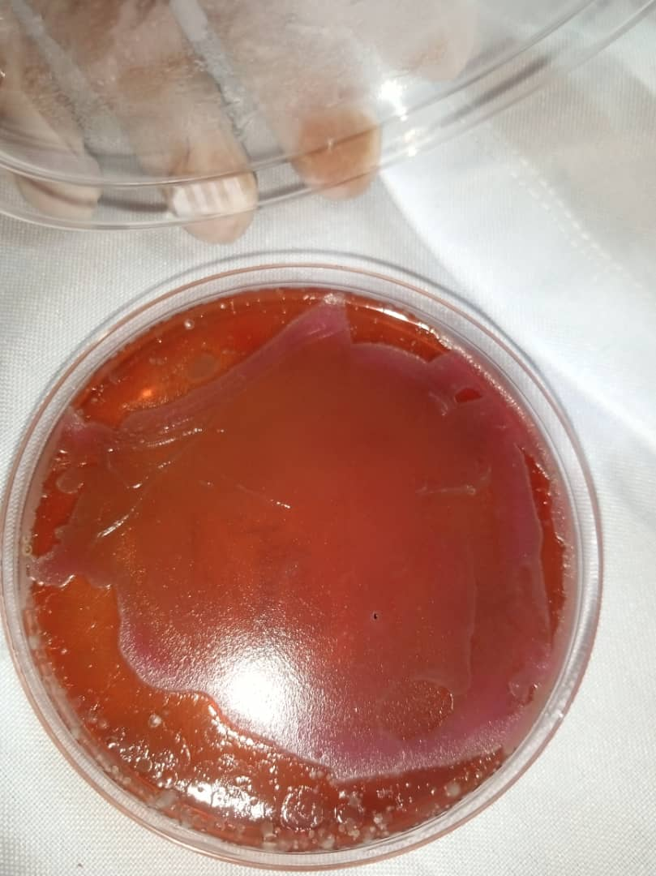

**Figure 7: Colony morphology of bacteria isolate**.

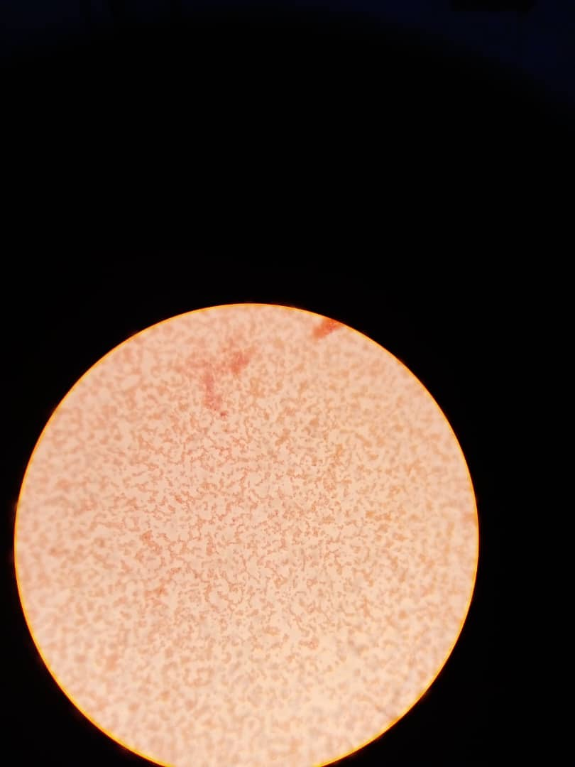

**Figure 8 : Microscopic appearance of Gram negative bacteria.**

**3.5 Occurrence of Fungal Isolates found in Insects Isolated from both Hospitals**

Fungi isolate that were prevalent in nosocomial environment were identified. *Aspergillus* spp, *Rhizopus* spp and *Penicillium* spp. *Aspergillus* spp showed the highest occurrence in nosocomial environment (Table 9).

**Table 9: Identification of fungal isolates**

|  |  |  |  |
| --- | --- | --- | --- |
| **Isolates code** | **Colony morphology** | **Microscopy** | **Organism present** |
| 11 | Circular, yellow-like, fluffy colony. | Long septate hyphae | *Aspergillus spp* |
| 5 | Dark grayish brown and are globose in shape. | Coenocytic hyphae with rhizoids | *Rhizopus spp* |
| 13 | Blue-green with a velvety like surface | Septate hyphaes with conidiophores | *Penicillium* spp |
| 7 | Dark green, wooly texture | Septate hyphae with brown conidiophores | *Aspergillus spp* |
| 1 | Brownish colour with a velvety texture and a reverse side of yellow colouration. | Septate hyphae, hyaline that are smooth walled conidiophores. | *Aspergillus spp* |
|  |  |  |  |

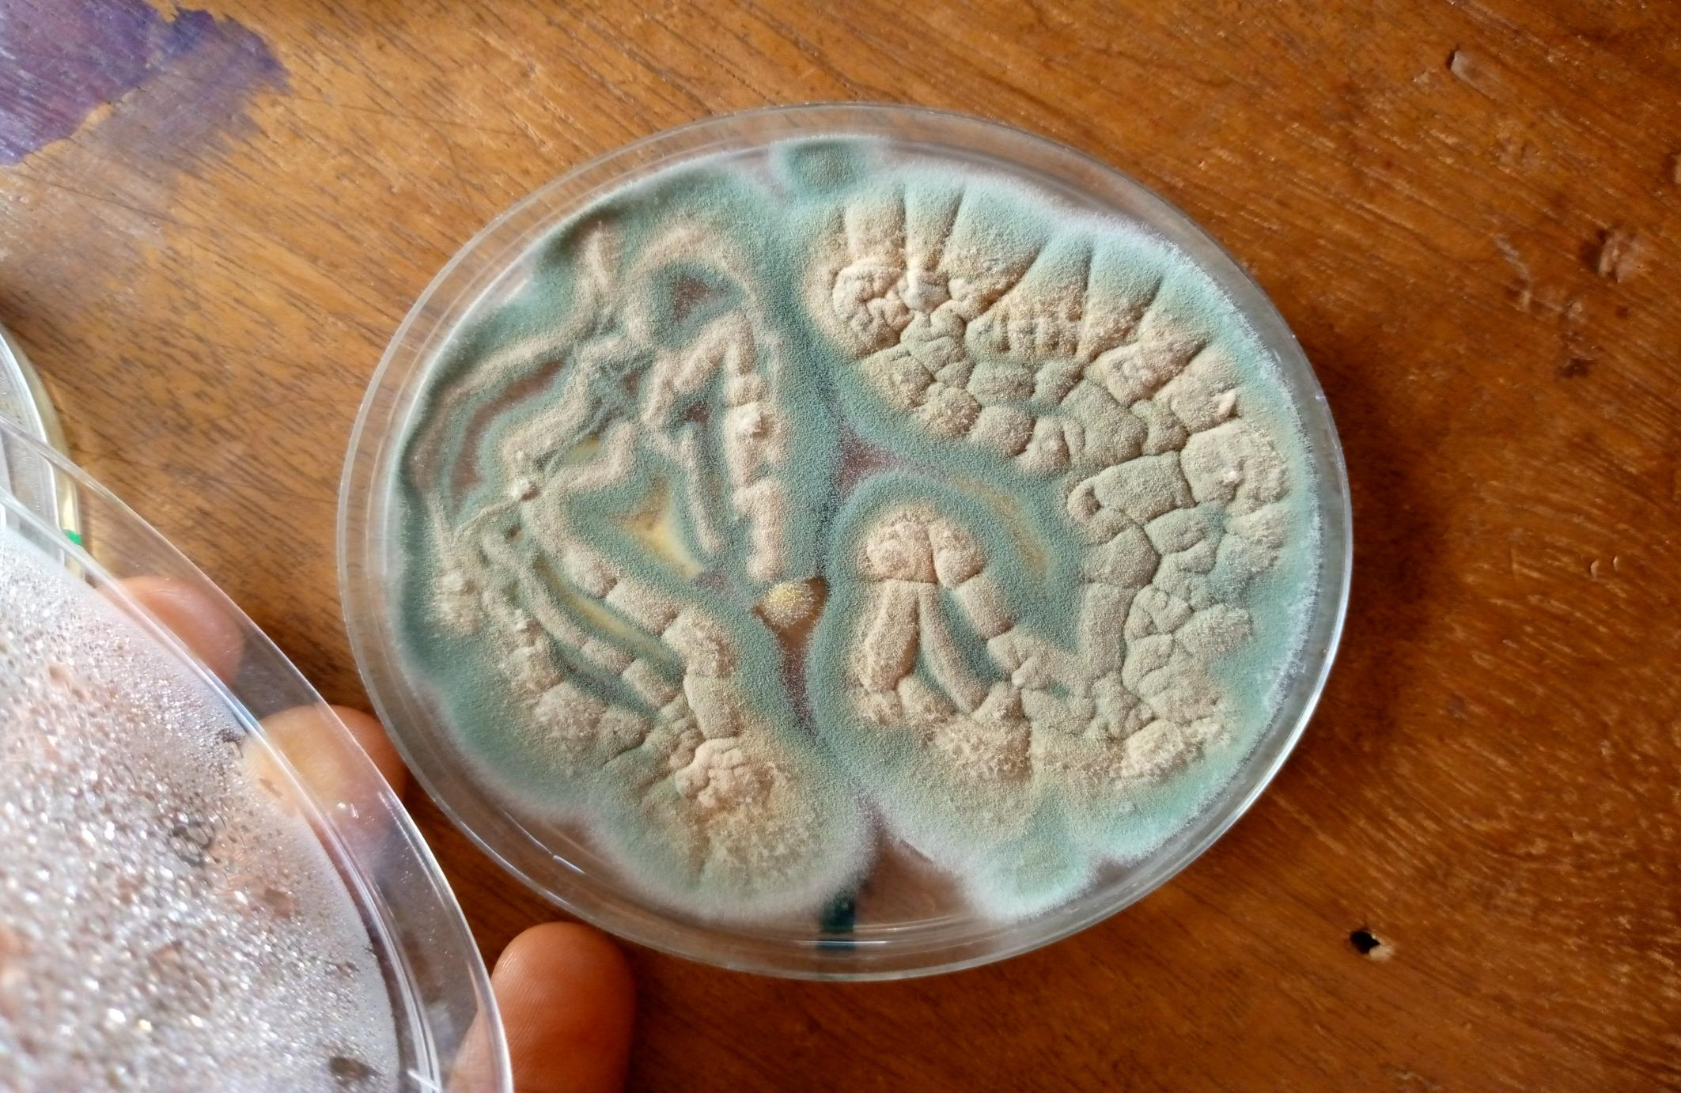

**Figure 9: Colony morphology of *Aspergillus spp***

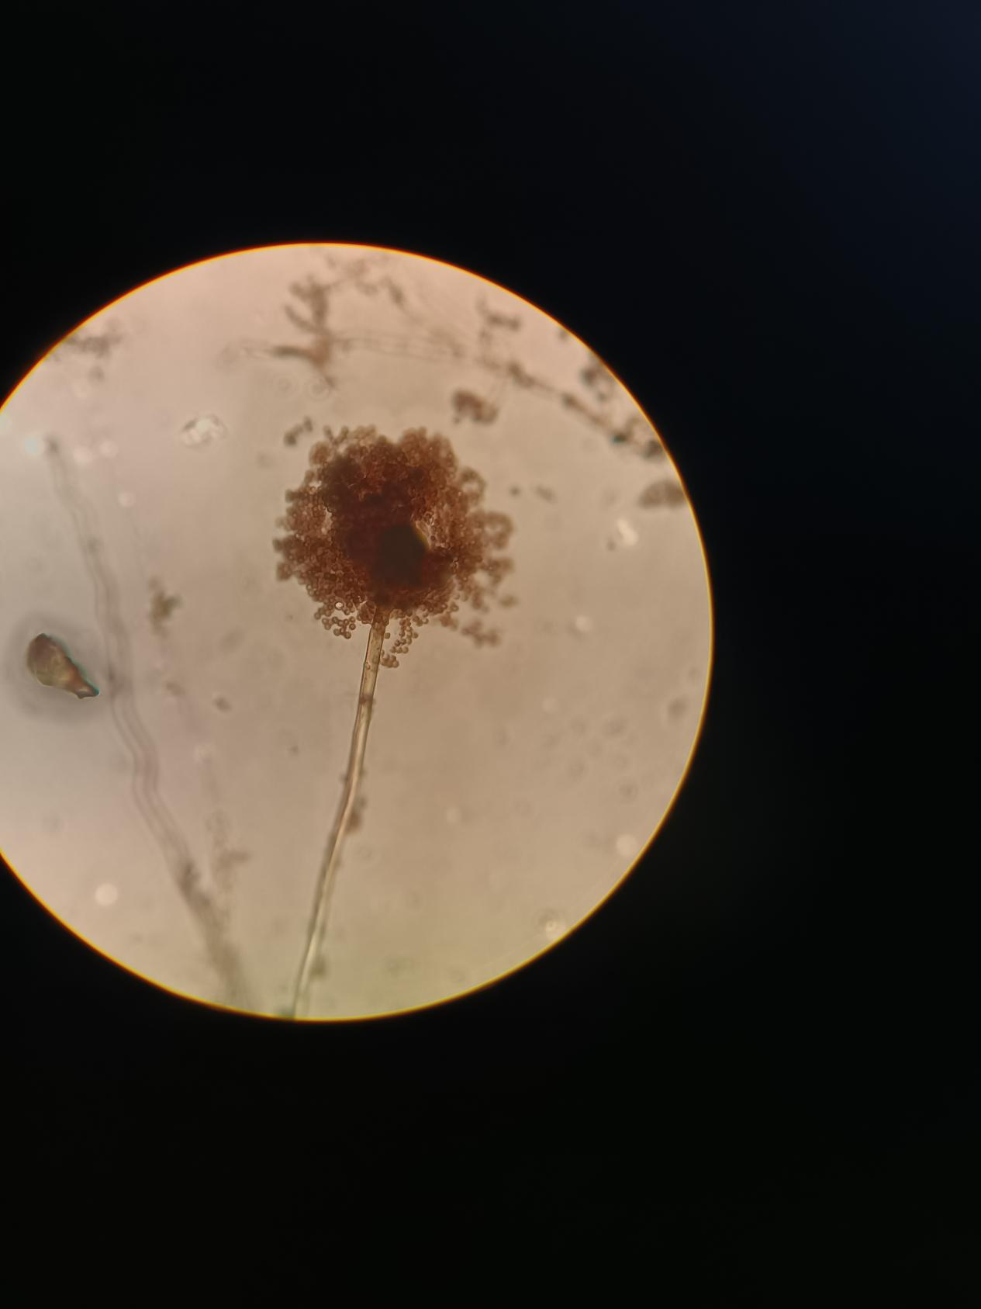

**Figure 10: Microscopic view of *Aspergillus spp****.*

**CHAPTER FOUR**

**DISCUSSION**

Insects are considered vectors of pathogens. They transfer microorganisms from decaying matter, waste, or faeces to objects and food, posing the risk of infection in humans. Among insects, various species of flies, ants, and cockroaches play a crucial role (Wiktorczyk-Kapischke *et al*., 2021). Insects represent the most successfully adapted group of animals on Earth, with over 1.5 million identified species (Belluco *et al*., 2023). Insects have established themselves in nearly every imaginable habitat and form the biological basis of all terrestrial ecosystems. They play critical roles such as decomposing and cycling nutrients, dispersing seeds, maintaining soil structure and fertility, and regulating populations of other organisms through various roles, including predators, parasites, parasitoids, disease agents, and vectors. Additionally, insects are a crucial food source for numerous other taxa, including amphibians, reptiles, birds, fish, arthropods, other invertebrates, and mammals (Van Huis, 2013). The widespread presence and diverse ecological niches of insects make them significant to public health from multiple viewpoints. In addition to their essential ecological functions, insects can impact public health by transmitting diseases to humans and animals. Biting insects, in particular, act as vectors and pests. With climate change and rising resistance among arthropods to insecticides, the prevalence and significance of vector-borne diseases are anticipated to grow in the near future (Poma *et al*., 2017). This research study encompasses a wide range of insects (i.e both crawling insects and flying insects) from Medical Centre and Faith Foundation Hospital in Nsukka, Enugu state.

Table 4 shows the Phenotypic tests results and suspected organism, according to Akpan *et al.* (2017) *Pseudomonas aeruginosa* is a gram-negative, rod-shaped bacterium that is commonly found in the environment, particularly in water and soil. It is an opportunistic pathogen that can cause a range of infections, also according to Rawat *et al.* (2023), *Enterococcus feacalis* and *Enterococcus feacium* has been found to reside in insects around hospital environment. They are also responsible for *Staphylococcus aureus* resistance to vancomycin, this was also observed in this study where we able to isolate *Bacillus* spp*, Staphylococcus* spp, *Pseudomonas* spp, *Proteus* spp, *Morganella* spp, *Enterobacter* spp*, Enterococcus* spp, *Escherichia coli,* and *Corynebacterium spp. Bacillus* spp showed the highest occurrence with a percentage of 30.43%, followed by *Pseudomonas* spp., *Morganella* spp, *Corynebacterium* spp, and *Staphylococcus aureus* showed the lowest level of occurrence in both hospitals with a percentage of 4.35%. This occurrence makes this a high risk for patients and heath workers. *P. aeruginosa* is known for its ability to form biofilms, which are complex communities of bacteria that are embedded in a protective matrix. This makes it resistant to antibiotics and the host's immune system (Akpan *et al.*, 2017).

*E. feacalis* on the other hand causes a broad range of nosocomial Infections including urinary tract infections (UTI's), bloodstream infections, endocarditis (infection of the heart valves, meningitis, respiratory tract infections (Parlapani *et al*., 2020). According to Kraupner *et al*. (2021) resistant fecal bacteria are more common in hospitals than in the general community, there may be a higher proportion of resistant bacteria in hospital wastewater. Furthermore, increased rates of resistant genes or bacteria may be an indication of on-site selection due to elevated antibiotic concentrations there. All the *Bacillus* spp were susceptible to ciprofloxacin (100%) and exhibited 100% resistance to amoxacillin. Susceptibility of *Enterococcus* spp to ciprofloxacin and gentamicin was similar (75%), while showing 100% resistance to amoxacillin and ampiclox. *Pseudomonas* spp were absolutely susceptible (100%), to tarivid, pefloxacin, and ciprofloxacillin, with 100% resistance to amoxacillin. However, variation in the susceptibility profile was observed among the *Proteus* spp. While both *Proteus* spp isolates were 100% susceptible to septrin, ciprofloxacin, tarivid, pefloxacin, sparfloxacin, and gentamicin, one of the *Proteus* spp. (MC32) was susceptible to all the antibiotics tested. On the other hand, 20% resistance was observed in one of the *Proteus* spp. (MC23) when tested against chloramphenicol and amoxacillin. *Escherichia coli* showed susceptibility of 100% to streptomycin and gentamicin and resistant to amoxacillin (100%). *Enterobacter* spp. showed 100% susceptibility to gentamicin, augmentin, amoxacillin, and chloramphenicol, then 100% resistance to septrin, and streptomycin. *Corynebacterium* sp. was susceptible to 60% of the antibiotics including streptomycin, pefloxacin, gentamicin, cirprofloxacin, septrin and erythromicin. It was also found to be intermediate dose dependent to rocephin, while it was 30% resistant to zinnacef, apiclox and amoxacilliin. *Staphylococcus aureus* was susceptibile to septrin, pefloxacin, cirprofloxacin, rocephin, erythromycin, gentamicin and streptomycin. It was however, resistant to amoxacillin, apiclox and zinnacef. It could be deduced from the antimicrobial susceptibility results that cirprofloxacin, pefloxacin, erythromycin, septrin, streptomycin and gentamicin are highly effective in treating nosocomial infection while the ineffective antibiotics are augumentin, amoxacillin, apiclox and zinaceff. The cost of care and mortality associated with HAI acquisition rise significantly, especially if the isolates are extensively or multidrug resistant (MDR/XDR). In this study, a total of isolates were multi-drug resistant. The distribution of the MDR isolates showed that 66.67% (n=12/18), were from the Faith Hospital samples, while 33.3% originated from the Medical Centre. Simultaneously, only one isolate from the Faith Hospital samples was not a MDR isolate. This indicates that the tendency of patients getting infected with MDR strains is very high in Faith Hospital than Medical Centre. Overuse of insecticides in many hospital environments may contribute to high carriage of multi-drug resistant microorganisms. Only Proteus species showed statistically significant differences in antibiotic susceptibility when compared to *Enterococcus* species (p-value = 0.0269). From these samples, fungi were also isolated in equal measure, with *Aspergillus s*pecies being the most prevalent. The widespread occurrence of Aspergillus species in the environment could account for this high incidence of occurrence.

**Conclusion**

This study successfully isolated and identified pathogenic microorganisms from various insects collected from hospital environments and assessed their antibiotics susceptibility. The finds revealed that hospital-associated insects harbor a diverse range of pathogenic bacteria, including multi drug resistant strains such as *Escherichia* *coli, Staphylococcus aureus, Pseudomonas aeruginosa,* and *Klebsiella pneumoniae.*

The results underscore the potential role of hospital insects as vectors in the transmission of hospital-acquired infection (HAIs). The high occurrence of antibiotics-resistance bacteria in these insects suggests a critical need for effective pest control measures and robust infection prevention strategies in health settings. This study emphasizes the importance of monitoring and controlling insect population within hospitals to reduce the risk of HAIs and improve patient safety.

**REFERENCES**

Akpan, N., Anwan, E., and Antia, U. (2017). Housefly (*musca domestica*) as a carrier of pathogenic microorganisms in hospital environments in calabar, nigeria. *Suranaree Journal of Science and Technology*, **24**(2).

Allegranzi, B., Nejad, S. B., Combescure, C., Graafmans, W., Attar, H., Donaldson, L., and Pittet, D. (2011). Burden of endemic health-care-associated infection in developing countries: systematic review and meta-analysis. *Lancet*, **377**(9761): 228–241. https://doi.org/10.1016/s0140-6736(10)61458-4

Belluco, S., Bertola, M., Montarsi, F., Di Martino, G., Granato, A., Stella, R., Martinello, M., Bordin, F., & Mutinelli, F. (2023). Insects and Public Health: An Overview. *Insects*, **14**(3): 240. https://doi.org/10.3390/insects14030240

Belluco, S., Losasso, C., Maggioletti, M., Alonzi, C. C., Paoletti, M. G., & Ricci, A. (2013). Edible Insects in a Food Safety and Nutritional Perspective: A Critical review. *Comprehensive Reviews in Food Science and Food Safety*, **12**(3): 296–313. https://doi.org/10.1111/1541-4337.12014

Breathnach, A. S. (2013). Nosocomial infections and infection control. *Medicine*, **41**(11): 649–653. https://doi.org/10.1016/j.mpmed.2013.08.010

Collins, A. S. (2008). *Preventing Health Care–Associated infections*. Patient Safety and Quality - NCBI Bookshelf. https://www.ncbi.nlm.nih.gov/books/NBK2683/

Danasekaran, R., Mani, G., & Annadurai, K. (2014). Prevention of healthcare-associated infections: protecting patients, saving lives. *International Journal of Community Medicine and Public Health* **1**(1): 67. https://doi.org/10.5455/2394-6040.ijcmph20141114

Donkor, E. S. (2019). Nosocomial Pathogens: An in-depth analysis of the vectorial potential of cockroaches. *Tropical Medicine and Infectious Disease*, **4**(1): 14. https://doi.org/10.3390/tropicalmed4010014

Fasolato, L., Cardazzo, B., Carraro, L., Fontana, F., Novelli, E., & Balzan, S. (2018). Edible processed insects from e-commerce: Food safety with a focus on the *Bacillus cereus* group. *Food Microbiology*, **76***:*296–303. https://doi.org/10.1016/j.fm.2018.06.008

Fonseca, A. R., Batista, D. R., Amaral, D. P. D., Campos, R. B. F., & Silva, C. G. (2010). Formigas (Hymenoptera: Formicidae) urbanas em um hospital no município de Luz, Estado de Minas Gerais. *Acta Scientiarum. Health Sciences*,32(1). https://doi.org/10.4025/actascihealthsci.v32i1.5805

Fontana, R., Da C Wetler, R. M., Aquino, R. S. S., Andrioli, J. L., Queiroz, G. R. G., Ferreira, S. L., Nascimento, I. C. D., & Delabie, J. H. C. (2010). Disseminação de bactérias patogênicas por formigas (Hymenoptera: Formicidae) em dois hospitais do nordeste do Brasil. *Neotropical Entomology/Neotropical Entomology*, **39**(4):655–663. https://doi.org/10.1590/s1519-566x2010000400029

Fürnkranz, U., and Walochnik, J. (2021). Nosocomial infections: Do not forget the parasites!. *Pathogens*, **10**(2), 238.

Garofalo, C., Osimani, A., Milanović, V., Taccari, M., Cardinali, F., Aquilanti, L., Riolo, P., Ruschioni, S., Isidoro, N., & Clementi, F. (2017). The microbiota of marketed processed edible insects as revealed by high-throughput sequencing. *Food Microbiology*, **62**:15–22. <https://doi.org/10.1016/j.fm.2016.09.012>

Kraupner, N., Hutinel, M., Schumacher, K., Gray, D. A., Genheden, M., Fick, J., Flach, C., & Larsson, D. J. (2021). Evidence for selection of multi-resistant E. coli by hospital effluent. *Environment International*, *150*, 106436. https://doi.org/10.1016/j.envint.2021.106436

Naher, A., Afroz, S., & Hamid, S. (2018). Cockroach Associated Foodborne Pathogens: distribution and antibiogram. *Bangladesh Medical Research Council Bulletin*, **44**(1): 30–38. https://doi.org/10.3329/bmrcb.v44i1.36802

Parlapani, F. F., Kyritsi, M., Sakka, M., Chatzinikolaou, K., Donos, S., Boziaris, I. S., and Athanassiou, C. G. (2020). Matrix-assisted laser desorption ionization–time of flight mass spectrometry reveals *Enterococcus* and *Enterobacter* spp. in major insect species involved in food security with resistance to common antibiotics. *Journal of Pest Science*, **93**:159-170.

Poma, G., Cuykx, M., Amato, E., Calaprice, C., Focant, J. F., & Covaci, A. (2017). Evaluation of hazardous chemicals in edible insects and insect-based food intended for human consumption. *Food and Chemical Toxicology*, **100:** 70–79. https://doi.org/10.1016/j.fct.2016.12.006

Rawat, N., Sabu, B., Jamwal, R., Devi, P. P., Yadav, K., Raina, H. S. and Rajagopal, R. (2023). Understanding the role of insects in the acquisition and transmission of antibiotic resistance. *Science of The Total Environment*, *858*, 159805

Revelas, A. (2012). Healthcare - associated infections: A public health problem. *Nigerian Medical Journal/Nigerian Medical Journal*, **53**(2): 59. https://doi.org/10.4103/0300-1652.103543

Ricchizzi, E., Latour, K., Kärki, T., Buttazzi, R., Jans, B., Moro, M. L., Nakitanda, O. A., Plachouras, D., Monnet, D. L., Suetens, C., & Kinross, P. (2018). Antimicrobial use in European long-term care facilities: results from the third point prevalence survey of healthcare-associated infections and antimicrobial use, 2016 to 2017. *Euro Surveillance/Eurosurveillance*, **23**(46): https://doi.org/10.2807/1560-7917.es.2018.23.46.1800394

Thomson, J. L., Yeater, K. M., Zurek, L., & Nayduch, D. (2016). Abundance and accumulation ofEscherichia coliandSalmonellaTyphimurium procured by male and female house flies (Diptera: *muscidae)* exposed to cattle manure. *Annals of the Entomological Society of America*, *110*(1), 37–44. https://doi.org/10.1093/aesa/saw082

Van Huis, A. (2013). Potential of insects as food and feed in assuring food security. *Annual Review of Entomology*, **58**(1): 563–583. <https://doi.org/10.1146/annurev-ento-120811-153704>

Wiktorczyk-Kapischke, N., Skowron, K., Kwiecińska-Piróg, J., Białucha, A., Wałecka-Zacharska, E., Grudlewska-Buda, K., Kraszewska, Z., & Gospodarek-Komkowska, E. (2021). Flies as a potential vector of selected alert pathogens in a hospital environment. *International Journal of Environmental Health Research*, **32**(8): 1868–1887. https://doi.org/10.1080/09603123.2021.1919605

Yin, C., Sun, P., Yu, X., Wang, P., & Cheng, G. (2020). Roles of symbiotic microorganisms in arboviral infection of arthropod vectors. *Trends in Parasitology*, **36**(7): 607–615. <https://doi.org/10.1016/j.pt.2020.04.009>

Zurek, L., Schal, C., & Watson, D. W. (2000). Diversity and Contribution of the Intestinal Bacterial Community to the Development of *Musca domestica* (Diptera: *Muscidae*) Larvae. *Journal of Medical Entomology*, **37**(6):924–928. <https://doi.org/10.1603/0022-2585-37.6.924>

**APPENDIX**

|  |  |  |  |  |  |  |  |  |  |  |
| --- | --- | --- | --- | --- | --- | --- | --- | --- | --- | --- |
| ISOLATES  CODE | PEF | CN | APX | Z | AM | R | CPX | S | SXT | E |
| MC1  MC2  MC7  MC21  MC26  FH7  FH13  FH15  FH17  FH21  FH25  FH27 | 26, 22  26, 28  26,22  Res, Res  28,26  18, 26  26, 22  12, 24  18, 16  24,28  14, 12  18,18 | 28,24  28, 24  28,26  14,12  14,16  14,18  16,20  20, 16  16,14  Res,Res  12,12  18,16 | Res, Res  Res, Res  16,12  Res,12  Res, Res  16,16  16,18  14,20  Res, Res  12, Res  12,Res  16,16 | Res,  Res  Res, Res  16,14  Res, Res  Res,12  14,16  14,20  16,20  Res, Res  14,Res   1. 14   Res,12 | Res, Res  Res, Res  14,16  Res,12  Res,Res  26,28  26,22  Res, Res  Res, Res  Res,Res  Res,16  Res,Res | 28,24  Res, 12  24,12  ±6  Res,Res  28,26  16,14  16,16  16,20  18,14  26,28  ± 1  16,14 | 28,26  26, 22  28,28  28,28  26,28  Res, Res  12,14  14,22  24,26  22,28  Res, Res  28,28 | 28, 28  12,14  268,26  Res, Res  28,26  12, Res  Res, Res  14,16  Res, Res  Res. 14  Res,12  18,18 | 26,28  26,24  28,28  Res,Res  28,24  12,14  12,16  22,20  Res,Res  Res, 16  Res,16  18,18 | 26,28  28,28  24,26  14,16  24,28  12,12  *16,24*  20, 18  14,Res  16,16  Res,Res  20,18 |

|  |  |  |  |  |  |  |  |  |  |  |
| --- | --- | --- | --- | --- | --- | --- | --- | --- | --- | --- |
| ISOLATES  CODE | CPX | AM | AU | CN | PEF | OFX | S | SXT | CH | SP |
| MC14  MC19  MC27  MC21  MC26  FH7  FH13  FH15  FH17  FH21  FH25  FH27 | 28,26  28,28  26,22 | 12,14  Res, Res  Res,12 | 16,12  14,16  12,14 | 26,22  28,24  Res,Res | 28,26  28,26  22,20 | 28,26  28,28  22,20 | 28,26  Res, Res  12,16 | 26,24  Res,Res  14,14 | 28,24  Res, Res  28,26 | 28,24  14,16  26,26  12,12  *16,24*  20, 18  14,Res  16,16  Res,Res  20,18 |